MyFootballClub SELF REGISTRATION GUIDE

2018 PENSHURST WEST FOOTBALL CLUB REGISTRATION GUIDE
This guide has been prepared to serve as a reference for all members to register for the 2018 Season. All Registration is required to be completed through MyFootballClub. MyFootballClub is the National Online Registration Database.

The following guide will assist you in completing this process. Further information is available on the MyFootballClub website (www.myfootballclub.com.au).

Should you encounter any issues with your registration please do not hesitate to contact the support contacts below:

Football NSW Staff:
(02) 8814 4449 samanthad@footballnsw.com.au (business hours, email after hours and weekends)
(02) 8814 4448 samuelk@footballnsw.com.au (business hours – 9am-5pm Mon-Fri)
OR
FFA MFC Support Centre
(02) 8020 4199 myfootballclub@footballaustralia.com.au

This document covers the following:

Creating/Finding Your FFA Number;
Logging into your MyFootballClub Profile;
Registering to your Club;
Creating/Finding Your FFA Number;

LOGGING INTO MyFootballClub

STEP 1 – SELECT THE OPTION WHICH IS RELEVANT TO YOU:
A. I know my FFA number and am ready to proceed to the login screen to retrieve my password and/or begin my registration. Click on the link below and proceed to Step 4
https://live.myfootballclub.com.au/SelfReg/login.aspx?ReturnUrl=/SelfReg/default.aspx
B. I have been registered as a player, coach, official or referee before but need to find my FFA number. Click on the link below and proceed to Step 3
https://live.myfootballclub.com.au/Signup/FFAMemberSignup.aspx
C. I have never been registered before and would like to set up an FFA account (generate an FFA number). Click on the link below and proceed to Step 2
https://live.myfootballclub.com.au/Signup/FFAMemberSignup.aspx?StartAt=Waivers

CREATING A NEW ACCOUNT

STEP 2 – CREATE NEW ACCOUNT
Complete the following form ensuring you complete all mandatory fields marked with an asterisks. After filling in your personal details you will be able to set the password for your new account – the password must be at least 5 characters long. When complete, click on the “Create Account” button at the bottom of the screen.

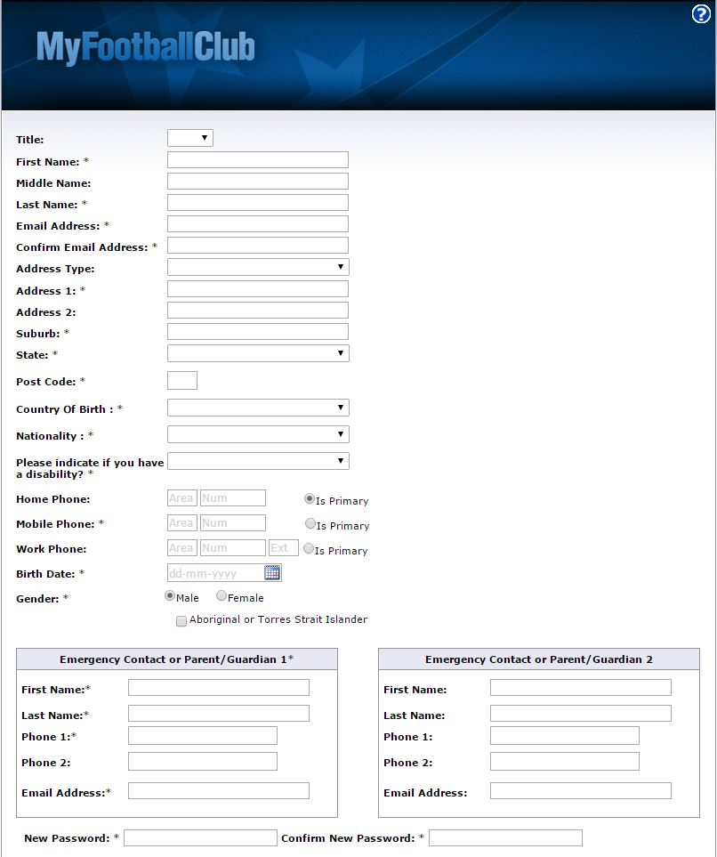

An email will be sent to your nominated email address with your FFA number and password from no-reply@myfootballclub.com.au.

When you have received this information proceed to the login screen (Step 4) (https://live.myfootballclub.com.au/SelfReg/login.aspx?ReturnUrl=/SelfReg/default.aspx)

FINDING YOUR DETAILS

STEP 3 – SEARCH FOR YOUR DETAILS
If you already have an FFA number however you do not remember it, you can retrieve your FFA Number here: https://live.myfootballclub.com.au/Signup/FFAMemberSignup.aspx.
a. Enter your first name, surname and date of birth in the relevant fields. If your name does not appear, try entering the first initial of both your first and surname along with your date of birth (this will allow the system to still search for you if your name has been entered incorrectly by your previous club) and click “Search”.

b. If your name appears in the bottom of the screen, click on it and you will be taken to the login screen. Proceed to Step 4

c. If you cannot find your FFA Number, please contact MyFootballClub or Football NSW on the details provided on page one and eight.

MyFootballClub LOGIN

STEP 4 – LOG IN
To login to your FFA account please visit the MyFootballClub login page here: https://live.myfootballclub.com.au/SelfReg/Login.aspx?chkcookie=1&ReturnUrl=/selfreg/default.aspx

a. Enter your FFA number & password. If your login details are correct, please proceed to Step 5

b. If you do not have a password click on “need a password”

c. Enter your email address that was nominated on your profile and select “Proceed”. If this data matches an email will be sent to you with your new password. Go back to the first login screen and proceed to Step 5.

d. If the email address entered does not match the one that is in MyFootballClub, you will automatically be redirected to a new screen to validate your account.
Note: When entering in “Last Known Club” type slowly and you will see Club names matching what you have entered appear under the box. Select the correct one.
e. If the data matches, the screen to the right will appear, please enter in your current email address. An email will be sent to you with your new password. Go back to the login screen and enter your new details. Proceed to Step 5.
If you cannot login or you are not receiving your new password please contact support on the details provided on page one and eight.

REGISTRATION

STEP 5 – REGISTRATION
After you have successfully logged into your account you will see the screen below.

Select the “Register” button.

You will be asked to check and update your personal details then click “Next”.

Step 5 Continued over page……

Photos should be of head and shoulders only (passport style photo). Any photos that do not meet the requirements will deem the registration invalid.

REGISTRATION continued

STEP 5 – REGISTRATION continued

- Step 1 of the Select Registration page will auto-populate with your last registered Club, if you are registering to that club move on to the next step.

If you are registering to a club different to your last registered Club you will need to delete the text showing in Step 1. Start typing in “Penshurst West Football Club ”, a drop down list will appear with all possible matches, please ensure you select the correct club as above:

Club that matches text above (Club)
Another Club name here (Club)
2018 Club as entered above in red (club)
Be sure to select the correct Club (Club)
There may be many matches for your Club Name (team)
Type Club name here

Step 5 Continued over page……

If the Club in Step 1 has no registration packages available you will receive the following dialog box:

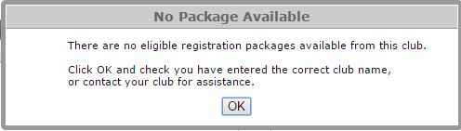

Click “OK” – you will then need to either re-enter the correct Club name or contact your Club about your registration.

Step 5 Continued over page……

REGISTRATION continued
- Select the applicable registration type to you: “PLAYER/COACH or VOLUNTEER”.
YOUR 2018 CLUB WILL BE HERE

- In the next drop down field select the appropriate package for your registration.
APPLICABLE PACKAGES FOR YOU
YOUR 2018 CLUB NAME W

- Click “Add Packages” then select the “Next” button.
YOUR 2018 CLUB NAME WILL BE
YOUR 2018 CLUB NAME WILL B
YOUR SELECTED PACKAGE
YOUR 2018 CLUB NAME WILL BE HERE Player Outdoor Your Package Name

- You will then be taken to the Terms and Conditions. You must read through and agree to all terms prior to being able to proceed through to the next steps. After reading, scroll to the bottom of the page and select “Next”.
Step 5 Continued over page……

REGISTRATION continued

- You will then be taken to the Payment screen. Click on “Pay Now” to pay online via Credit Card (VISA or MasterCard), or select “Manual Payment at Club”.
Your selected Registration Package Name will be here
Your 2018 Club Name will be here

- After selecting “Next” you will be taken to a screen confirming your registration has been submitted.
Your Invoice Message will appear in this area
Club Contact Details will be on this page
Your 2018 Club Name will be here

SUPPORT

SUPPORT CONTACTS
Football NSW Staff:
(02) 8814 4449 samanthad@footballnsw.com.au (business hours, after hours and weekends)
(02) 8814 4448 samuelk@footballnsw.com.au (business hours – 9am-5pm Mon-Fri)
OR
FFA MFC Support Centre
(02) 8020 4199 myfootballclub@footballaustralia.com.au
www.myfootballclub.com.au

